PHH: Change in Seal sample
On 21/08/2017, Hong Ha Viet Nam Joint Stock Company announced the change in Seal sample as follows:
- Seal sample
Old seal | New seal
: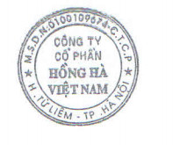 | 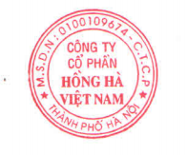
- Effective date: 21/08/2017

